History of the Joy of All Who Sorrow Orthodox Church
on the Westside of Los Angeles, CA

The Joy of All Who Sorrow Orthodox Church was born out of love for God and a desire to serve the Westside neighborhoods of Los Angeles. The mission began in Venice Beach as the Bookstand on the Strand, which evolved into a one-car garage chapel for worship. An influx of communicants and ever-expanding hope for a permanent Orthodox presence on the Westside drew many to embrace this effort. Soon, the mission grew into a two-car garage chapel at the home of Fr. John Tomasi, and eventually landed on a busy street in Culver City, CA.

In 1999, the Archangel Michael Orthodox Bookstore was established, also in Culver City, which housed a small, often-used sanctuary, in a cozy 1,200 square foot building. The bookstore continues to stock hundreds of books, icons, lampadas, incense and burners, as well as gift items from around the globe. In the autumn of 2000, the Orthodox Church in America (OCA) formally accepted the mission under its wing with its new name: Joy of All Who Sorrow Orthodox Church.

For over 12 years, the Joy of All Who Sorrow parish resided in its third location (on Sepulveda Boulevard in Culver City), and has moved to its fourth, now in Marina Del Rey, CA, just north of the 90 Freeway. We are always hoping to find a permanent location that will allow our parish to expand and grow perpetual roots in the Westside of Los Angeles. People of all ages come into our community to pray for one another and for the world in these challenging times. Benefactors, as founders in this endeavor, are welcomed to contribute! No gift is too small, for we believe that with faith as a grain of mustard seed….nothing shall be impossible [Mat 17:20].

You will find us on Facebook @JoyOrthodoxLA. Please “like” and “follow” to view our many live-streamed services and classes. We also have a YouTube page where you will find various postings. Simply Subscribe and click on the bell to receive notices of video postings.: https://www.youtube.com/channel/UC3Az7XYmlHUIbiDY-AomD_A

Joy of All Who Sorrow (OCA) & Archangel Michael Orthodox Bookstore
4161 Lincoln Blvd, Marina Del Rey, CA 90292
Church/Bookstore: 310-391-9911 To Leave a Message: 310-849-9451
www.joyofallwhosorrow.org

All Donations are Tax Deductible
JOY OF ALL WHO SORROW
ORTHODOX CHURCH (OCA)

Church Bulletin & Announcements
February 14 – 27, 2023

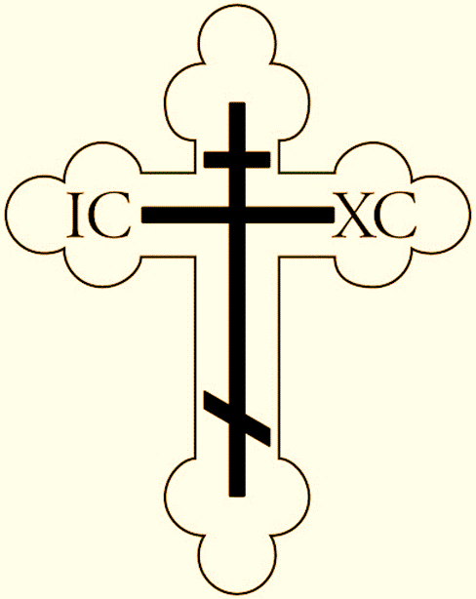
WELCOME!
FACE MASKS: Please feel free to wear a face mask in our worship services if that makes you feel more comfortable, and for the safety of all who attend. We ask that you stay home if you are sick. Thank you for keeping our church safe from harm!

ONGOING CHURCH SERVICES AND EVENTS: We continue to live-stream our services and classes on Facebook. Feel free to like and follow Joy of All Who Sorrow Orthodox Church, Culver City, CA, on Facebook: @JoyOrthodoxLA. The bookstore also has its own Facebook page to follow: Facebook@ArchangelMichaelOrthodoxBookstore

Our Website: www.joyofallwhosorrow.org

SUNDAY DIVINE LITURGY BEGINS AT 10:00 A.M. All Sunday and weekday services are held at 4161 Lincoln Blvd., Marina Del Rey, CA, 90292.

BOOKSTORE HOURS: Bookstore hours are Wednesday-Saturday, 1:00 p.m. to 7:00 p.m., and on Sundays until 2:00 p.m. Off-hours visits can also be arranged by calling Matushka Deborah at 310-849-9451. Additionally, the bookstore is open and available after all services in the church. Feel free to ask choir members or altar servers for assistance.

SCHEDULE OF SERVICES & CLASSES: February 14-27, 2023

Tuesday, February 14 His Grace, Bishop Tikhon’s Funeral Today
6:00 p.m. Vigil: The Meeting of our Lord Live on Facebook

Wednesday, February 15 GREAT FEAST: The Meeting of our Lord and Savior
7:00 a.m. Divine Liturgy Live on Facebook
6:00 p.m. Vespers (St. Nicholas of Japan; St. Innocent) “ “
6:30 p.m. Akathist to St. Nicholas the Wonderworker “ “
7:00 p.m. “Studies in the Faith” Class (Fr. John Tomasi) “ “

Thursday, February 16 St. Symeon, Proph. Anna, St. Nicholas of Japan, St. Innocent
7:00 a.m. Divine Liturgy Live on Facebook
6:00 p.m. Vespers (St. Isadore of Pelusium) “ “

Friday, February 17 Strict Fast Day
6:00 p.m. Vespers (Commemoration of the Departed) Live on Facebook
6:30 p.m. Akathist to the Mother of God “ “

Saturday, February 18 Commemoration of the Departed
7:00 a.m. Matins & Hours Live on Facebook
8:30 a.m. Divine Liturgy “ “
10:00 a.m. Panikhida (Saturday of the Departed) “ “
3:00 p.m. Choir Practice at Church
5:00 p.m. Resurrection Vigil & Dread Judgement Sunday “ “

Sunday, February 19 Sunday of the Dread Judgement (Last day to eat meat)
10:00 a.m. Divine Liturgy Live on Facebook
Tone: 3 Epistle: I Cor. 6:12-20 Gospel: Mat. 25:31-46
2:00 p.m. PARISH COUNCIL MEETING via ZOOM
Monday, February 20 Civil Holiday: Presidents’ Day (Lincoln & Washington)
6:00 p.m. Vespers (Apodosis; Gr. Martyr Theodore) Live on Facebook
Tuesday, February 21 Apodosis of the Feast; Gr. Martyr Theodore Stratelates
7:00 a.m. Divine Liturgy Live on Facebook
6:00 p.m. Vespers (St. Innocent of Irkutsk) “ “

Wednesday, February 22 Cheese-Fare Fast: No Meat; St. Innocent of Irkutsk
7:00 a.m. Divine Liturgy Live on Facebook
6:00 p.m. Vespers (Hieromartyr Charalampus +202) “ “
6:30 p.m. Akathist to St. Nicholas the Wonderworker “ “
7:00 p.m. “Studies in the Faith” Class (Fr. John Tomasi) “ “

Thursday, February 23 Cheese-Fare Week: No Meat
6:00 p.m. Vespers (St. Isadore of Pelusium) Live on Facebook

Friday, February 24 Cheese-Fare Week: No Meat
6:00 p.m. Vespers (Commemoration of Ascetics) Live on Facebook

Saturday, February 25 Commemoration of the Ascetics (Cheese-Fare: No Meat)
7:00 a.m. Matins & Hours Live on Facebook
8:30 a.m. Divine Liturgy “ “
3:00 p.m. Choir Practice at Church
5:00 p.m. Resurrection Vigil & Forgiveness Sunday “ “

Sunday, February 26 FORGIVENESS SUNDAY (Expulsion/Adam from Paradise)
10:00 a.m. Divine Liturgy Live on Facebook
Tone: 4 Epistle: Rom. 13:11-14:4 Gospel: Mat. 6:14-21
11:30 a.m. Forgiveness Sunday Vespers & Forgiveness of Others
12:30 p.m. BLINI FUNDRAISER FOR CHURCH (Approx. Time)

Monday, February 27 CLEAN MONDAY: First Day of Great Lent
7:00 a.m. Matins & 1st Hour Live on Facebook
6:00 p.m. Compline, Canon of St. Andrew of Crete “ “

ANNOUNCEMENTS

- HOW TO SET UP DONATIONS USING “ZELLE” OR “TITHELY”: For no-fee Zelle instructions, go to: https://www.zellepay.com/how-it-works and for Tithely: https://get.tithe.ly/start. We are listed as Joy of All Who Sorrow Orthodox Church with both sources (Zelle still has us in “Culver City).

- “FORGIVENESS SUNDAY” WILL BE ON FEBRUARY 26, 2023:
On Forgiveness Sunday, we all gather for vespers and beg forgiveness of one another, in preparation for the 40-day fast that starts the next day.

- THE FIRST WEEK (Feb. 27-Mar. 3) OF GREAT LENT: The Great Canon of St. Andrew of Crete will be included in Compline starting at 6pm (M-Th), and in the mornings at 7am we will have either Matins or Presanctified Liturgy. An Akathist to the Theotokos will be on Fridays at 6pm throughout Great Lent.

- TO MAKE A CONFESSION APPOINTMENT: Fr. John will hear confessions during Saturday Vigils, or call Father at 310-749-0524 to set a time.

